# Controller

The control of battery current is the requirement defined as system requirement. The control topology has been defined in Figure 1 in the simulation report. The sense current is processed and the processed current information is provided to gate driver. The desired output current is 2A.

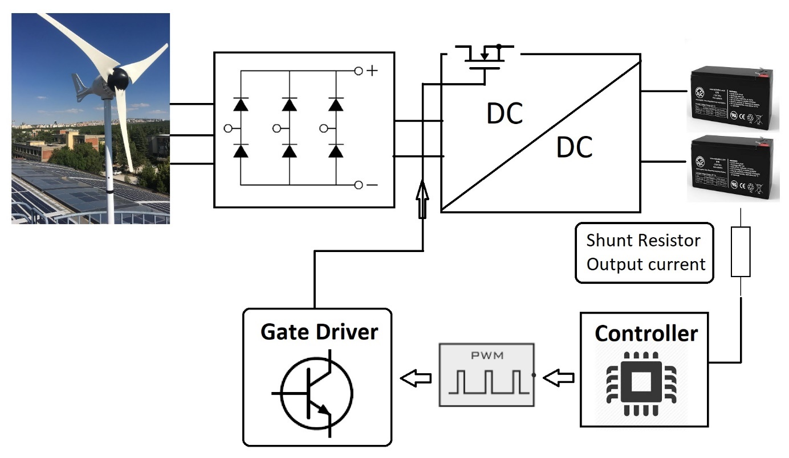

Figure Block diagram of system and controller

The controller simulations are handled with PI controller block in Matlab/Simulink. The current ripple is satisfied with in limits defined by min current and max current lines as seen in Figure 2. The frequency is selected as 50kHz for the simulation.

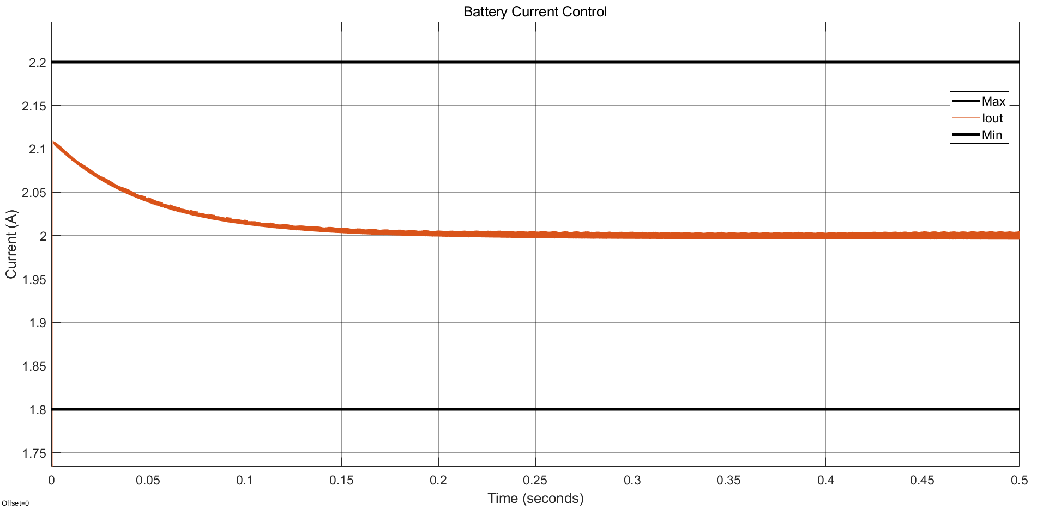

Figure Battery current control with PI controller in Simulink

Controller selection is the one of time consuming part of the project. The vast majority of manufactured controllers have low voltage limits and digital controllers restricts the system to usage of isolation. Isolation is disadvantage due to high size and cost. On the other hand, low cost and size can be gained from internal gate driver controller. The desired controller is all in one. Table 1 shows different type of manufactured controllers.

Table Summary of different type of controllers

|  |  |  |
| --- | --- | --- |
| Type | Includings | Limits |
| Switcher | * Switch * Controller * Gate driver | Low input voltage levels  Low power applications |
| External regulator | * Controller * Gate driver | Low voltage levels |
| Digital controller | * Controller | Isolation |

The controller research has expanded to find an all in one type of controller within voltage limits. As a result of research, led driver controllers have been found. The represented led driver, AL9910A, has replaced with led driver, HV9961 controller. The functional block diagram of AL9910A and HV9961 controllers can be seen in Figure 3.

The both led driver can control the current with sense resistor, linear dimming and PWM dimming. Since the current of battery is constant, the sense resistor is used. The controller directly connected to input voltage and linear voltage regulator is used to get constant voltage for internal components such as gate driver. Sensed output current is compared with reference. Then, the gate driver turns on and off the switch according to comparison, which is hysteresis control. However, HV9961, have average current control logic inside. The comparison of the former and the latter led driver controller is shown in table xxx.

|  |  |  |
| --- | --- | --- |
|  | AL9910A | HV9961 |
| Input voltage range | * 20V - 520V | * 10V - 450V |
| Switching type | * Non-synchronous | * Non-synchronous |
| Control | * Current sense * Linear dimming * PWM dimming | * Current sense (Average control) * Linear dimming * PWM dimming |
| Swithching frequency | * Constant fsw * Constant Toff | * Constant Toff |
| Soft-start | * External (Capacitor connection to LD pin) | * External (Capacitor connection to LD pin) |
| Price (1000 pieces) | * 0.84$ | * 1.15$ |

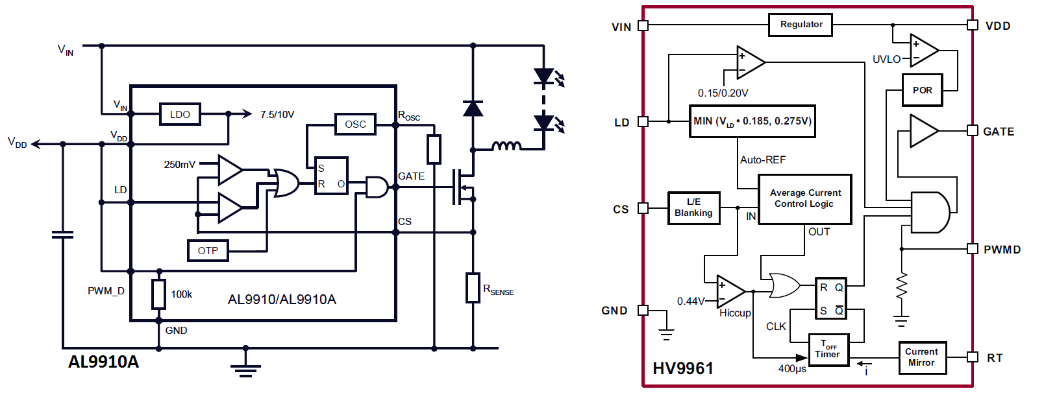

Figure Functional block diagrams of led driver controllers, AL9910A and HV9961

The HV9961 controller have average current control logic to decrease current ripple. The switching frequency of the controller changes due to characteristic of the controller. The constant off-time determination provides the converter with constant current ripple if inductance is sufficiently high, since output voltage and inductance value don’t change. The on-time changes according to input voltage. As the input voltage increases, on-time decreases so that frequency increases. Hence, the maximum limits of input voltage and current ripple determines maximum switching frequency as seen in Equation xxx.

|  |  |  |
| --- | --- | --- |
|  | $$ΔI_{L}=\frac{V_{out}\left(1-D\right)T_{s}}{L}= \frac{V_{out}{ T}_{off}}{L}$$ $$\frac{T_{on}}{T_{s}}=D= \frac{V_{out}}{V_{in}}$$ | (1) |

The off-time is adjusted from the RT pin of HV9961 controller according to Equation xxx.

|  |  |  |
| --- | --- | --- |
|  | $$T_{off}\left(μsec\right)=\frac{R_{T}(kΩ)}{25}+0.3, 30kΩ≤R_{T}≤1MΩ$$ | (2) |

HV9961 controller doesn’t have soft-starter. However, the characteristic of linear dimming provides the circuit with soft-start by external capacitor. Figure xxx shows the typical application circuit of HV9961. The capacitor connected to VDD, PWMD and LD pins of controller starts to charge up to VDD voltage initially. When the voltage on capacitor is lower than 1.5V, the linear dimming dominates the current reference voltage so that soft-start applies.

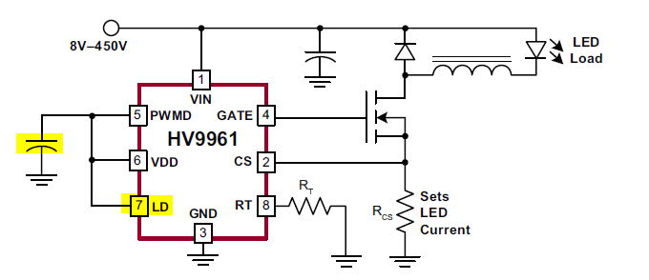

The HV9961 provides the system with low cost and small size. Also, because the switching frequency decreases as input voltage decreases, the switching losses decreases while the current ripple stays constant. On the other hand, the LDO decreases the efficiency of controller and the reference voltage of controller may results in a high resistive loss on shunt resistor as output current increases.

# Loss Calculations

The practical loss mechanisms are modelled and calculated according to datasheets of the components. The losses can be classified as swtiching losses and conduction losses. The losses of buck converter are shown in Table xxx.

The formal, AL9910A, controller have constant switching frequency and conduction losses that changes in parallel with the input voltage. On the other hand, the latter, HV9961, controller adjust the switching frequency according to the input voltage, so that switching loss depends on input voltage.

|  |  |  |
| --- | --- | --- |
| Loss mechanism | Component | Model |
| Conduction | Mosfet | $$P_{on,M}= \left[I_{out}^{2}+\frac{ΔI_{L}^{2}}{12}\right]R_{on,M} D$$ |
| Switching | Mosfet | $$P_{sw,M}= \frac{1}{2}V_{in}I_{out}\left(t_{rise}+t_{fall}\right)f_{sw}$$ |
| Switching – Output capacitance | Mosfet | $$P_{coss}= \frac{1}{2}V_{in}^{2}\left(C_{DS}+C_{GD}\right)f_{sw}$$ $$P_{coss}=E_{coss}{ f}_{sw}$$ |
| Switching – Gate charge | Mosfet | $$P_{G}=Q_{g}{ V}_{gs} f_{sw}$$ |
| Conduction | Diode | $$P_{on,D}=V_{f}I_{out}\left(1-D\right)$$ |
| Switching – Reverse recovery | Diode | $$P_{sw,D}=\frac{1}{2}V_{in} I_{rr}{ t}_{rr}{ f}_{sw}$$ |
| Conduction – Copper loss | Inductor | $$P_{L}=\left[I_{out}^{2}+\frac{ΔI_{L}^{2}}{12}\right]R_{L}$$ |
| Conduction | Shunt resistor | $$P_{shunt}=\left[I_{out}^{2}+\frac{ΔI_{L}^{2}}{12}\right]R_{shunt}$$ |

The contributions from different kind of loss mechanisms and total power loss of mosfet and diode are given in Figure 4 and Figure 5, respectively.

The conduction losses and switching losses of mosfet are dominant at low input voltages and high input voltages, respectively, which results from the change of frequency, reverse voltage and duty cycle. On the other hand, conduction losses of mosfet is dominat at both low input voltages and high input voltage due to high foward voltage of diode.

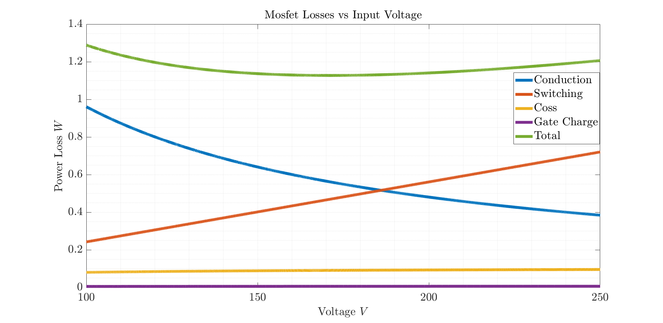

Figure Conduction, switching and total power losses of Mosfet

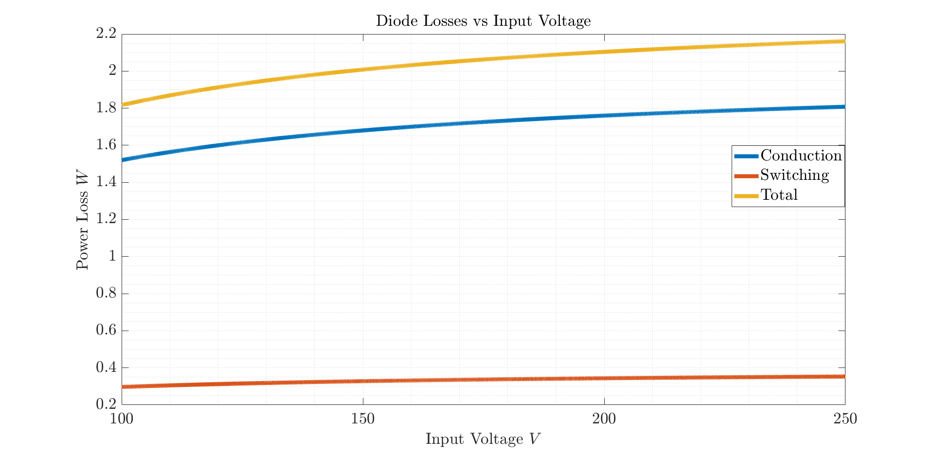

Figure Conduction, switching and total power losses of Diode

There are other loss mechanism due to resistive losses of inductor and shunt resistor. Since the output current pass through the inductor and shunt resistor, magnitude of the resistive losses depends on the output current. The power loss calculations for resistive losses are shown in Table 2.

Table Resistive losses of inductor and shunt resistance

|  |  |
| --- | --- |
| Component | Power Loss |
| Inductor | 1.485W |
| Shunt resistor | 0.548W |

# Thermal Calculations

The thermal calculations are hand calculations. The consideration for the thermal management is based on that each component generating heat is assumed as surrounded by air. The used thermal resistances are junction-to-case and case-to-ambient resistance to reveal whether heat-sink is needed or not.

The thermal calculation are processed iteratively. The junction temperature and on resistance of mosfet have direct relation. Hence, the resistance should be increased iteratively up to where founded junction temperature and assumed junction temperature are equal. The iterative steps for thermal calculation of mosfet is shown in Table 3. The junction-to-ambient thermal resistance is assumed 60°C/W.

The found maximum junction temperature of mosfet is calculated as 110°C. This value is calculated with maximum ratings of thermal resistance and power. The maximum junction temperature is 150°C. Hence, the safety region can be increased more for the sake of compensation of increase in ambient temperature. The safety region is increased with usage of PCB as a heatsink. The PCB

Table Iterative thermal calculations for Mosfet

|  |  |  |  |
| --- | --- | --- | --- |
| RthJA,TYP - RthJA,MAX: 35°C/W - 62°C/W | | | |
| **RDS** | **Assumed TJ - TA** | **Max. Power Loss** | **Calculated TJ** |
| 0.60Ω | 25°C - 25°C | 1.05W | 88°C |
| 0.95Ω | 88°C - 25°C | 1.24W | 99.4°C |
| 1.05Ω | 99.4°C - 25°C | 1.32W | 104.2°C |
| 1.10Ω | 104.2°C - 25°C | 1.38W | 107°C |
| 1.12Ω | 107°C - 25°C | 1.40W | 109°C |

The thermal calculations for the diode is given in Table xxx. The selected diode is type of through hole, so that the diode dissipates heat power from leads and case. The connection between diode and PCB is relatively small and thermal resistance of PCB is not as low as the thermal resistance of junction to ambient. Therefore, thermal calculation are calculated with consideration of heat transfer between case and air and the heat transfer between PCB and leads can be considered as safety margin.

|  |  |  |  |
| --- | --- | --- | --- |
| Forward Voltage - VF | Max. Power Loss | RthJA | Calculated Max TJ – TA |
| 1V | 2.16W | 20°C/W | 68.2°C – 25°C |

The thermal management of diode rectifiers are relatively easy compared to switching diode and mosfet. The power loss of diode rectifiers are considerably low since passing current through them is low and the switching frequency of rectifier diodes is approximately between the range 20-40Hz due to low poles number of generator.

Another important heat generators are inductor and shunt resistance. The inductor can dissipate the heat from copper if ambient temperatur is not high. Also, the operating temperature of inductors, motors and transformers are designed as 85°C. On the other hand, the shunt resistor is selected with consideration of resistive loss. Therefore, these components can stay cool sufficiently.